Attendance Policy
Version: | 1.0
Date created/updated: | 1st September 2023
Ratified by: | OLASH LGB
Date ratified: | 19th September 2023
Date issued: | 19th September 2023
Policy Review Date: | September 2024
Post Holder Responsible for Review: | Ms O’Beirne

Mission Statement
‘At Our Lady and St Hubert’s home, school and parish work together as we grow and learn that God is with us in all we do.’

Aims and Purpose
All members of the school community are treated with the respect and sensitivity implicit within our Catholic ethos and the practice of a code of equal opportunities and inclusion. Equality of treatment and opportunity operate regardless of background, ability, gender, religion, disability, or ethnicity.
This is a hardworking school, and your child plays their part in making it so. We aim for an environment which enables and encourages all members of the community to reach out for excellence. For our children to gain the greatest benefit from their education it is vital that they attend regularly, and your child should be at school, on time, every day the school is open unless the reason for the absence is unavoidable.
It is very important therefore that you make sure that your child attends regularly, and this policy sets out how together we will achieve this.
Why Regular Attendance is so important:
Any absence (including missing part of a lesson due to lateness) affects the pattern of a child’s schooling and regular absence will seriously affect their learning. Any pupil’s absence disrupts teaching routines so may affect the learning of others in the same class.
Ensuring your child’s regular attendance at school is your legal responsibility and permitting absence from school without a good reason is an offence in law and may result in prosecution.
The Law relating to attendance.
Section 7 of the Education Act 1996 states that ‘the parent of every child of compulsory school age shall cause him/her to receive efficient full-time education suitable:
a) to age, ability, and aptitude and
b) to any special educational needs, he/ she may have.
Either by regular attendance at school or otherwise’
Promoting Regular Attendance:
Helping to create a pattern of regular attendance is everybody’s responsibility - parents and carers, pupils and all members of school staff. Please refer to Appendix A for guidance on attendance and absence for all.
To help us all to focus on this we will:
• Report to you each term on how your child is performing in school, what their attendance and punctuality rate is and how this relates to their attainment and progress.
• reward good attendance by rewarding an Attendance trophy each week to the class with the best attendance; and
• reward good or improving attendance through certificates or prizes at the end of each term.
Understanding types of absence:
Every half-day absence from school must be classified by the school (not by the parents/carers), as either AUTHORISED or UNAUTHORISED. This is why information about the cause of any absence is always required.
Authorised absences are mornings or afternoons away from school for a genuine reason such as illness, medical/dental appointments but ONLY those which unavoidably fall in school time. Emergencies or other unavoidable causes would need to be assessed on each individual case.
Unauthorised absences are those which the school does not consider reasonable and for which permission has not been given. This type of absence may lead to the Local Authority using sanctions and/or legal proceedings. Examples of this include:
• parents/carers keeping children off school unnecessarily.
• absences which have never been properly explained.
• children who arrive at school too late to get an attendance mark in the register.
• shopping, looking after other children or birthdays; and
• day trips and holidays in term time which have not been agreed.
Whilst any child may be off school because they are ill, sometimes they can be reluctant to attend school. Any problems with regular attendance are best dealt with between school, the parents, and the child. If your child is reluctant to attend, it is never better to cover up their absence or to give in to pressure to excuse them from attending. This gives the impression that attendance does not matter and usually make things worse.
Parents who fail to ensure their child’s regular attendance can be fined £60 (per parent, per child). If the payment is not made within 21 days this increases to £120. The definition of “regular attendance” and the penalties open to schools for failing to ensure regular attendance were clarified by a Supreme Court judgement in May 2017 (see Appendix B).
As part of school policy, we will make a referral to the Attendance & Prosecution Service for pupils who take unauthorised leave of ten days or more over a school year and/or who have 10 unauthorised absence sessions (1 session = ½ day) in a four-week period.
Arrival after the register closes is classed as an unauthorised absence. Such a referral may lead to a Fixed Penalty Notice being issued.
Children’s absence due to illness where it leads to them missing days before or after a school holiday may also be classed as unauthorised unless a parent is able to provide medical proof of illness e.g. a prescription, stamped and dated surgery appointment card as we have several children who are frequently “ill” on these days according to parents, yet we know from other sources that they have gone on holiday.
Dental and GP appointments during the school day will only be authorised in exceptional circumstances such as for emergency or orthodontic treatment. Proof must be provided of all such medical, dental or hospital appointments and we would request that parents try to arrange any hospital appointments for school holidays or, if more urgent, the start or the end of the school day.

Persistent Absence (PA):
A pupil becomes a ‘persistent absentee’ when they miss 15% or more schooling for whatever reason. Absence at this level is doing considerable damage to any child’s education and we need parents’ fullest support and co-operation to tackle this.
Attendance at 90% or below
When a child has reached the 90% or below mark for any reasons, including genuine absences, school will write to parents to alert them and notify them that until their child’s attendance improves to above 90% no further absences will be authorised unless evidence is provided.
Evidence includes appointment cards; evidence of medicines being prescribed by a doctor or evidence of the circumstances necessitating the absence from school. If evidence is not provided, then any further absence will be unauthorised. There are consequences of unauthorised absence detailed below.
Please note this only applies for the period until your child’s absence reaches above 90%.
Attendance at 80% or below
When a child’s absence falls to 80% or below, we will have already been in contact several times and offered every support possible. School will write to parents to inform them that their child’s attendance has been referred to the Education Welfare Office who have legal powers to prosecute, issue penalty notices and make home visits. The Education Welfare Office is independent of the school and is part of the local authority.
Absence Procedures:
If your child is absent, you must:
•contact us as soon as possible on the first day of absence, ideally by 9.00am.
• or report to a member of the staff
•provide a reason for your child’s absence.
If your child is absent, we will:

•telephone you on the first day of absence if we have not heard from you.
In the event of persistent absence, we will:
•invite you in to discuss the situation with the attendance officer and a local education welfare officer (EWO).
•refer the matter to our EWO for possible intervention and if absence becomes persistent, we will also refer to the local authority Education Welfare Office if necessary.

Telephone numbers:
There are times when we need to contact parents/carers about lots of things, including absence, so it is your responsibility to provide school with your updated contact details. Help us to help you and your child by making sure we always have an up-to-date number – if we don’t then something important may be missed. There will be regular checks on telephone numbers throughout the year.
The Education Welfare Service:
Parents/carers are expected to contact school at an early stage and to work with the staff in resolving any problems together. This is nearly always successful. If difficulties cannot be sorted out in this way, the school may refer the child to the Education Welfare Service at the Local Authority. The Education Welfare Service (EWS) has access to all attendance information for each pupil and if your child is missing school without good reason, schools and the EA have the authority to find out why.
If your child is missing school without good reason, school has the right to find out why.
If your child is referred by school to the EWS for absenteeism, the EWS will first arrange for an Education Welfare Officer (EWO) to visit your home. This visit provides the EWO with an opportunity to assess whether your child’s absence is condoned by you as the parent(s) and if you can make sure your child attends school regularly.
The EWS will follow a process with you and your child to help make sure your child attends school regularly.
The EWS also works with other agencies (e.g., Social Services) to identify and deal with any complex needs that a family has.
Prosecutions against parents are used as a last resort where parents fail to engage with the service and continue to ignore their child’s educational and welfare needs.
Alternatively, parents or children may wish to contact the Education Welfare Office themselves to ask for help or information. Their telephone number is available from the school office or by contacting the Local Authority.

Children Missing from Education
Where reasonably possible, Our Lady and St Hubert’s Primary School will hold more than one emergency contact number for each pupil or student. This goes beyond the legal minimum. Our Lady and St Hubert’s Primary School will endeavour to make additional options to contact a responsible adult when a child missing education is also identified as a welfare and/or safeguarding concern.

A child missing from education, particularly repeatedly, may be a vital sign of a range of safeguarding possibilities. In line with KCSIE, September 2021 and Our Lady and St Hubert’s Primary School Safeguarding and Child Protection Policy 2021/22, we will work with parents and our local safeguarding partners, as required. Early intervention is necessary to identify the existence of any underlying safeguarding risk and to help prevent the risks of a child going missing in education in the future.
Lateness:
Being late is not acceptable. If your child misses the start of the day, they can miss vital learning and do not spend time with their class teacher getting vital information and news for the day. Late arriving pupils will also disrupt lessons, as at least one member of staff will in position of having to stop the task they are working on to address the child who has arrived late. Any child arriving late MUST be signed in at the ‘Late Gate’ which is at the main office. Failing to comply with this could result in school having to report your son or daughter without an adult to Social Services. This is the same rule for those collecting their son or daughter late after school. School will act if lateness in persistent.
How we manage lateness:
The school gates open at 8.40 am, to allow for parent/carers to be able to access school and respect our school neighbours in terms of parking. Parents/ carers are responsible for their children until 8.50am. If you send your child to school before 8.40am their safety is your responsibility, not school’s, until they enter the school building. If your child is late for school, it is your responsibility, not school’s, to ensure that they arrive in the school office and are signed in by you or another responsible adult who is accompanying your child. Until they are signed in at the school’s office when arriving late, they are in your care and their safety is your responsibility.

Registers are marked at 8.55 am and your child will receive a late mark if they are not in the classroom by that time.
If your child has a persistent late record, you will be asked to meet with the attendance officer to resolve the problem, but you can approach us at any time if you are having problems getting your child to school on time.
At 9.20 am the registers will be closed. In accordance with the regulations, if your child arrives after that time, they will receive a mark that shows them to be at school, but this will not count as a present mark, and it will mean they have an unauthorised absence.
If these late marks persist after the register has closed, we will:
• invite you in to discuss the situation with the attendance officer and a local education welfare officer (EWO).
• refer the matter to our EWO for possible intervention and if absence becomes persistent, we will also refer to the local authority Education Welfare Office if necessary.
If the problem persists after this intervention, you could face the possibility of a Penalty Notice.

Holidays in Term Time:
The school cannot authorise holidays being taken in term time as learning is disrupted and the lost time is detrimental to the educational progress of the child. Our Lady and St Hubert’s Primary School follows the DFE guidelines from September 2013 that states that request for long-term leave can only be granted or deemed granted without a formal request on the appropriate forms (available from the school office). Interviews following a request may be conducted prior to any decision being made. The school will not authorise any holidays retrospectively and may follow up any reported illness that we feel may have been a term time holiday. A visit may be made to the home in support of this.
Any period of absence taken without the agreement of the school, or exceeding that agreed, will be classed as unauthorised and may be referred to the EWO who may instigate sanctions such as a Penalty Notice. In some cases, the child may lose their school place (be removed from school roll) if there is a continuous period of unauthorised absence for 20 school days or more.

Please see Sandwell’s information leaflet on holidays during term-time which is attached to our attendance policy.
School targets, projects, and special initiatives:
The school has targets to improve attendance and your child has an important part to play in meeting these targets.
The minimum target level of attendance for this school is 97% and we will keep you updated regularly about progress to this level and how your child’s attendance compares.
Our target is to achieve better than this because we know that good attendance is the key to successful schooling.
Through the school year we monitor absences and punctuality to show us where improvements need to be made. Information on any projects or initiatives that will focus on these areas will be provided in letters home and we ask for your full support.
Summary:
Our Lady and St Huberts has a legal duty to publish its absence figures to parents/carers and to promote attendance. Equally, every parent/carer has a duty to make sure that their child/ren attends.

All school staff are committed to working with parents/carers and pupils as the best way to ensure as high a level of attendance as possible.

Appendix A
We Care About Our Children’s Attendance, Well-Being, Progress and Future
How can I work out how time missed from school affects my son/daughter’s attendance?

NUMBER OF DAYS ABSENT FROM SCHOOL | CHILD’S ATTENDANCE AT THE END OF THE YEAR
If your child has 1 day off school during the year will mean that… | …their attendance will be 99.5%.
If your child has 2 days off school during the year will mean that… | …their attendance will be at 99%.
If your child has 5 days off school during the year will mean that… | …their attendance will be at 97.4%.
If your child has 10 days off school during the year will mean that… | …their attendance will be at 95%.
If your child has 15 days off school during the year will mean that… | …their attendance will be at 92.4%.
If your child has 20 days off school during the year will mean that… | …their attendance will be at 90% AND school will now regularly monitor attendance on a regular basis. Letters home will be sent.
More than 20 days off school during the school year will mean that… | …their attendance will be below 90% and school may need to contact Education Welfare Service for Sandwell. This may lead to sanctions, court and penalties against the parents.

It has been worked out that 17 missed days of school per year can result in children achieving less than they were expected to at the end of the year. At Secondary school, this can be the difference between Grade 3 (which is equivalent to what was a C = PASS) and Grade 4 (which is equivalent to what was a D = FAIL). Whilst our children are not yet secondary school, we know that everyday counts, and we are building our children to be ready for the future. We want our children to have the best opportunities for their future.

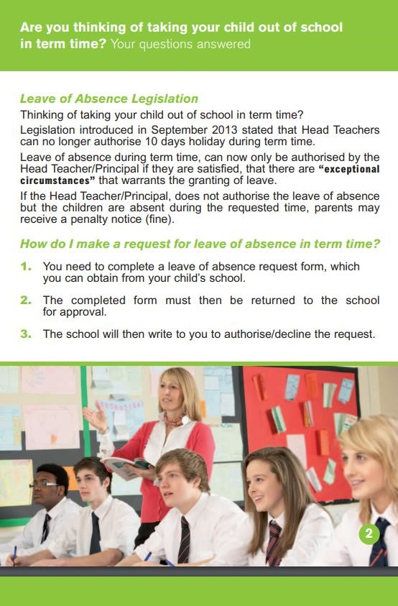
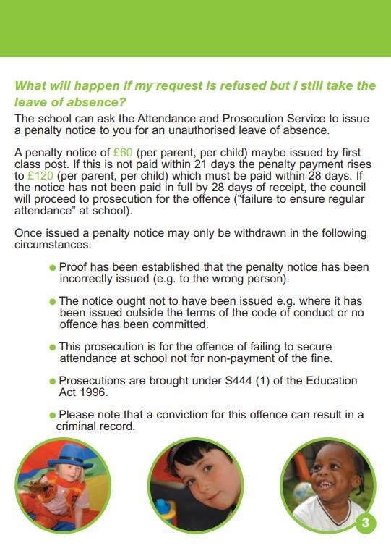
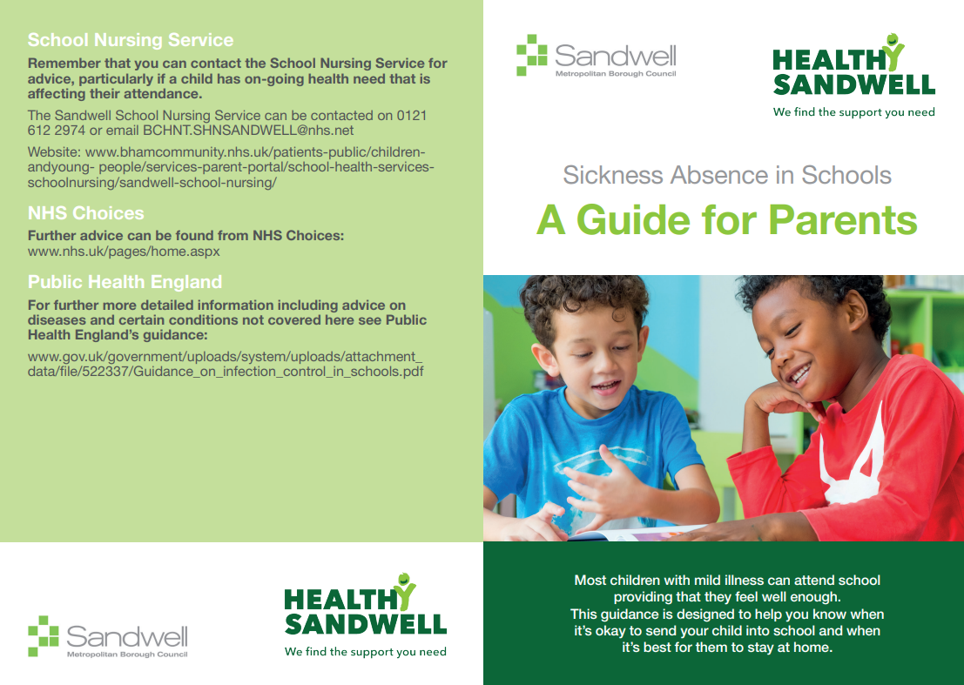
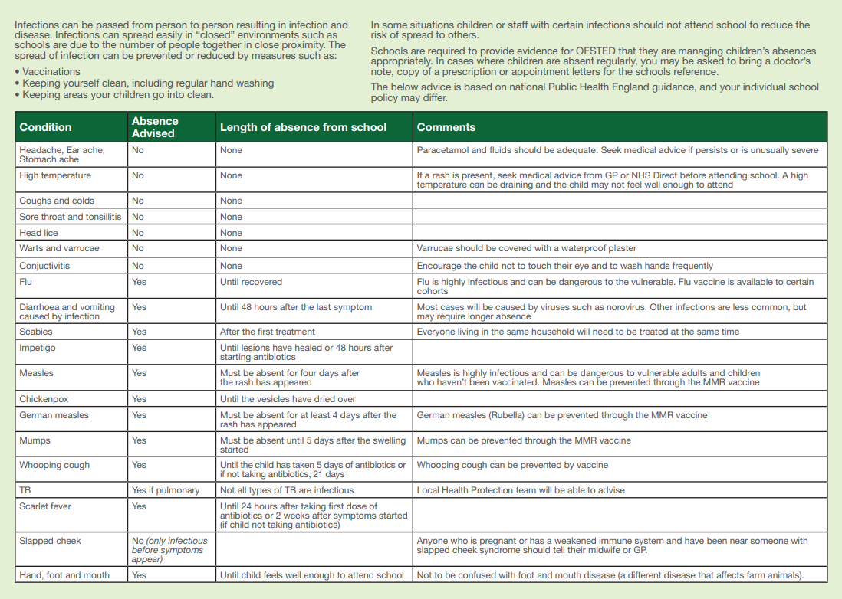
Commitment to Equality:
We are committed to providing a positive working environment which is free from prejudice and unlawful discrimination and any form of harassment, bullying or victimisation. We have developed. a number of key policies to ensure that the principles of Catholic Social Teaching in relation to human dignity and dignity in work become embedded into every aspect of school life and these. policies are reviewed regularly in this regard.

This Policy has been approved and adopted by Our Lady and St Hubert’s Catholic Primary School on 19th September 2023 and will be reviewed in September 2024.

Signed by the Chair of the Local Governing Body for Our Lady and St Hubert’s Catholic Primary School :

Mr Bernard King
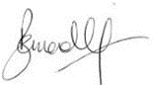

Signed by the Principal for Our Lady and St Hubert’s Catholic Primary School

Ms O O’Beirne

